**Experiment Number - 5**

**Student Name:** ANIKET KUMAR **UID:** 20BCS5306

**Branch:** CSE **Section/Group:** 20BCS_WM-703 / B

**Semester:** 5th **Date of Performance:** 11th Oct, 2022

**Subject Name:** PBLJ LAB **Subject Code:** 20CSP-321

1. **Aim/Overview of the practical:**

Write a program to collect and store all the cards to assist the users in finding all the cards in a given symbol.

This cards game consist of N number of cards. Get N number of cards details from the user and store the values in Card object with the attributes symbol and number.

Store all the cards in a map with symbol as its key and list of cards as its value. Map is used here to easily group all the cards based on their symbol.

Once all the details are captured print all the distinct symbols in alphabetical order from the Map. For each symbol print all the card details, number of cards and their sum respectively.

**2. Hardware and Software Requirements :**

PC with windows installed,IntelliJ IDEA (IDE).

**3. Program Code:**

import java.util.*;

public class TestMain {

public static void main(String[] args) {

Scanner input = new Scanner(System.in);

List<Integer> valueList = new ArrayList<Integer>();

TreeMap<String, List<Integer>> mapObj = new TreeMap<String, List<Integer>>();

int totalCards, index, value, sum = 0, count = 0;

System.out.println("Enter number of cards : ");

totalCards = input.nextInt();

String symbol;

for(index=1; index<=totalCards; index++) {

System.out.println("Enter card " + index + ":");

symbol = input.next();

value = input.nextInt();

if (mapObj.containsKey(symbol)) {

valueList = mapObj.get(symbol);

valueList.add(value);

}

else {

valueList = new ArrayList<Integer>();

valueList.add(value);

mapObj.put(symbol, valueList);

}

}

System.out.println("Distinct symbols are :");

for(Map.Entry<String, List<Integer>> getData : mapObj.entrySet()) {

System.out.print(getData.getKey() + " ");

}

System.out.println();

for(Map.Entry<String, List<Integer>> getData : mapObj.entrySet()) {

System.out.println("Cards in " + getData.getKey() + " Symbol :");

ArrayList<Integer> temp = (ArrayList<Integer>) getData.getValue();

Iterator<Integer> itr = temp.iterator();

while (itr.hasNext()) {

count++;

int val = (int) itr.next();

System.out.print(getData.getKey());

System.out.println(" " + val);

sum += val;

}

System.out.println("Number of cards: " + count);

System.out.println("Sum of cards: " + sum);

sum = 0;

}

}

}

**4. Output :**

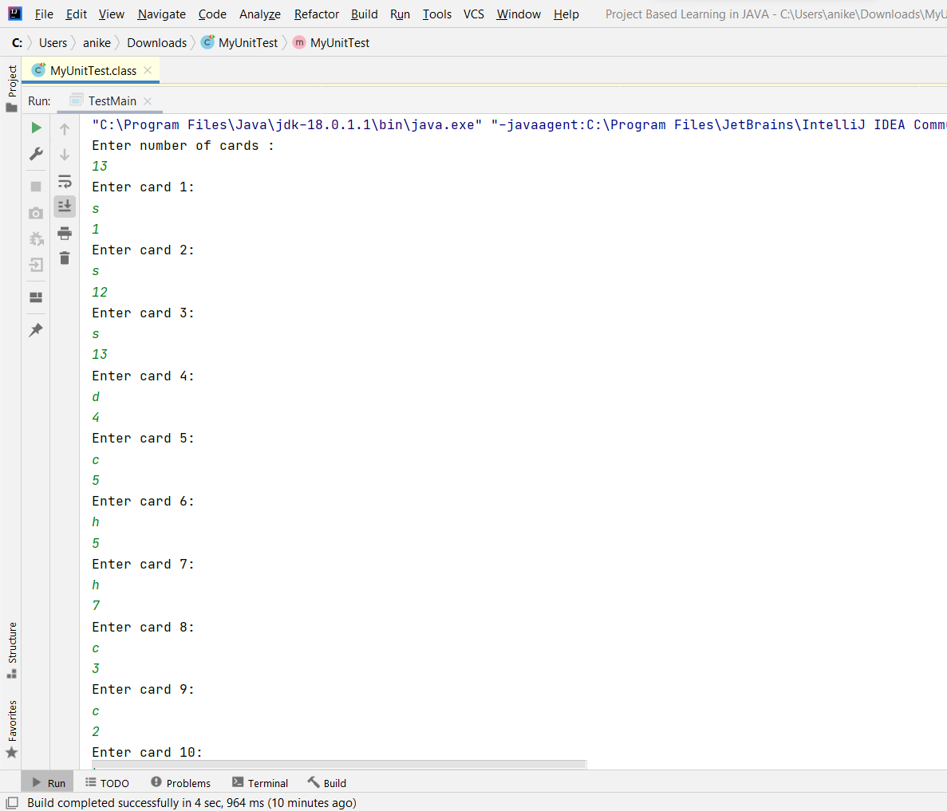

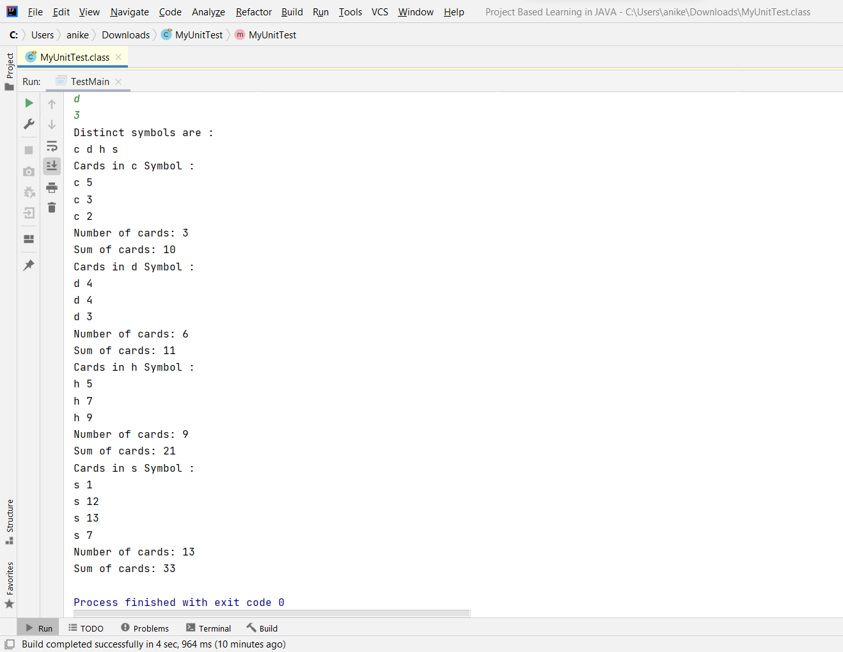

**Learning outcomes (What I have learnt):**

1. I have learnt how to write program in JAVA.
2. I have learnt how to create classes and its objects in JAVA.
3. I have learnt how to take input from user using Scanner class.
4. I have learnt how to create Array in JAVA and traverse each elements using loop.
5. I have learnt how to create an application to collect and store all the cards to assist the users in finding all the cards in a given symbol.

**Evaluation Grid (To be created as per the SOP and Assessment guidelines by the faculty):**

|  |  |  |  |
| --- | --- | --- | --- |
| Sr. No. | Parameters | Marks Obtained | Maximum Marks |
| 1. |  |  |  |
| 2. |  |  |  |
| 3. |  |  |  |
|  |  |  |  |